DDIC or Data dictionary

FROM SAP Easy Access menu, Go to Tcode SE11. Press Enter.

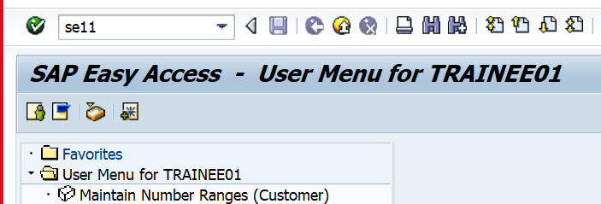

Enter table name as shown below. Click on Display

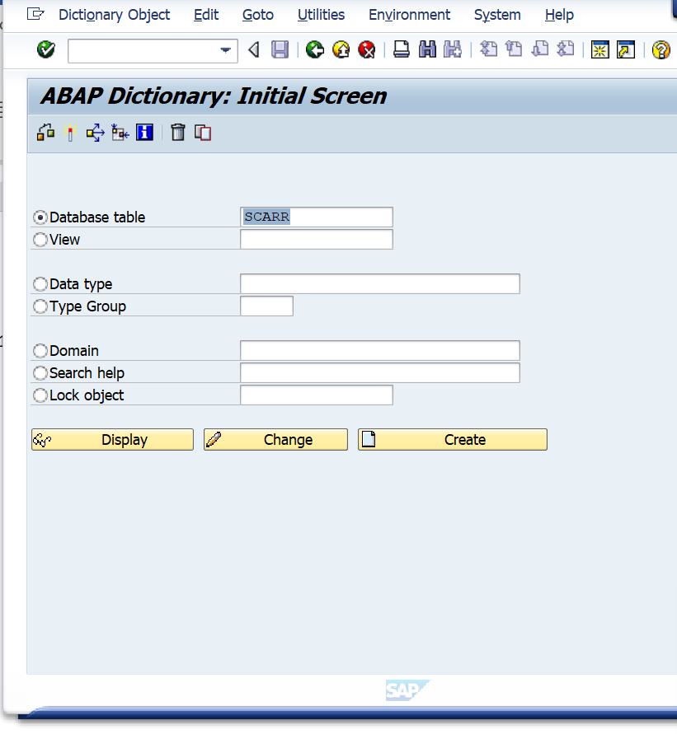

The structure of the tables with field names, data types and length are shown below.

View the contents of the table.

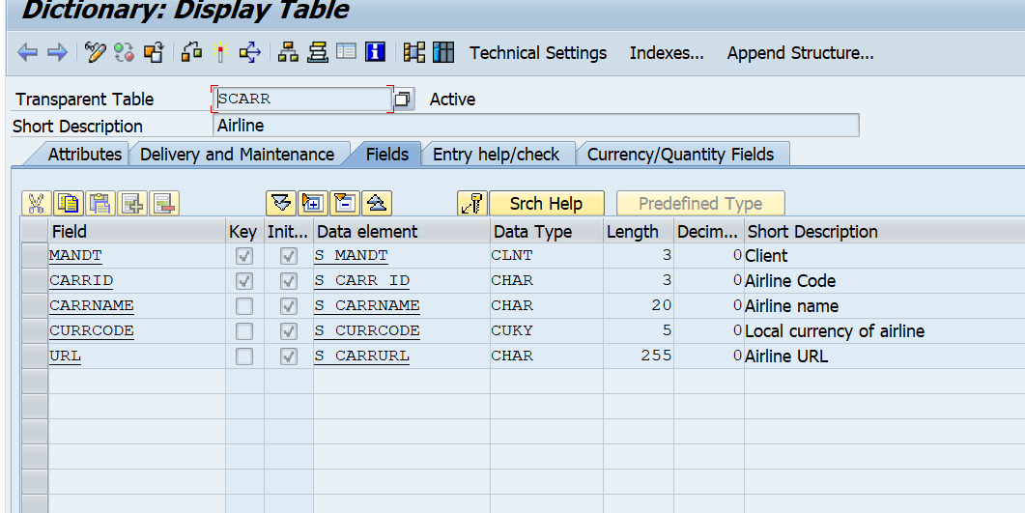

Click on Execute on the screen below.

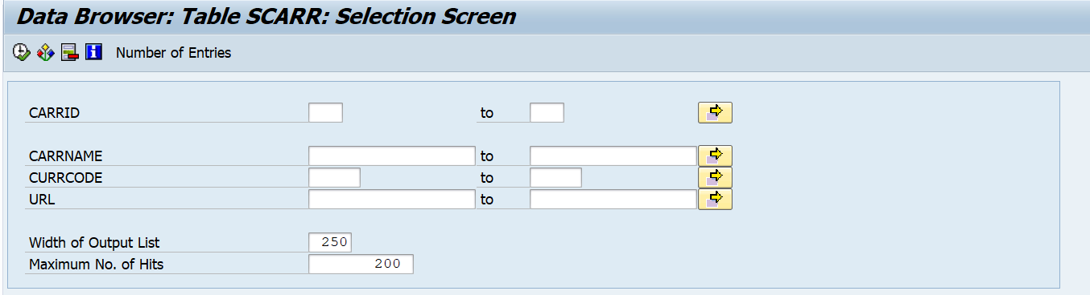

View the contents of the table. Click on Back to go back to the previous screen.

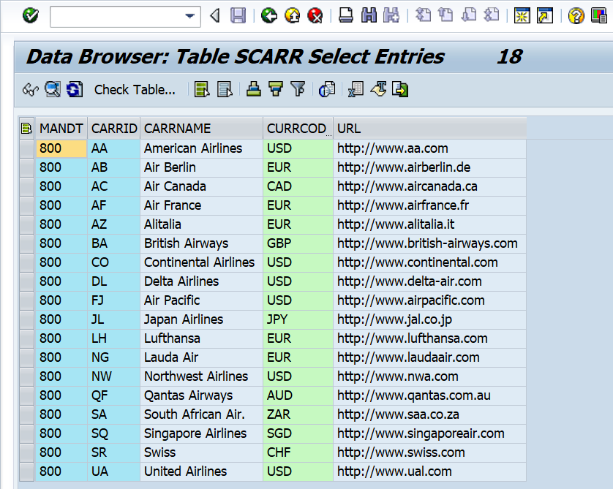

Enter Carrid as shown below and click on execute.

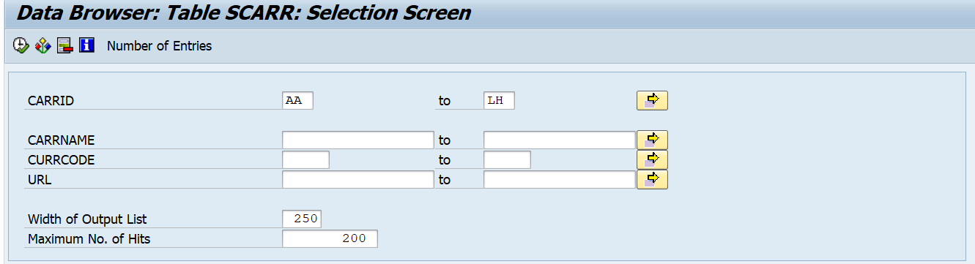

The screen shown above has fields with select options. The Carrid and /or carrname can be entered on the above screen to filter the records to be displayed.

View the contents of the table.

